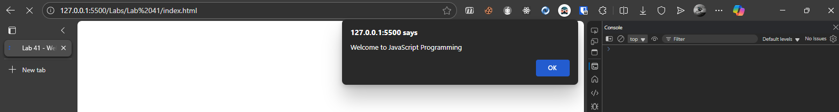

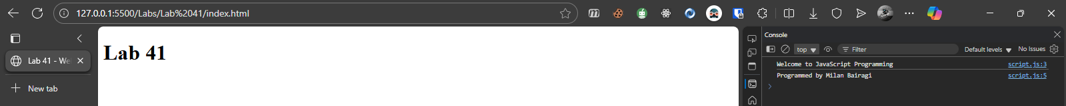

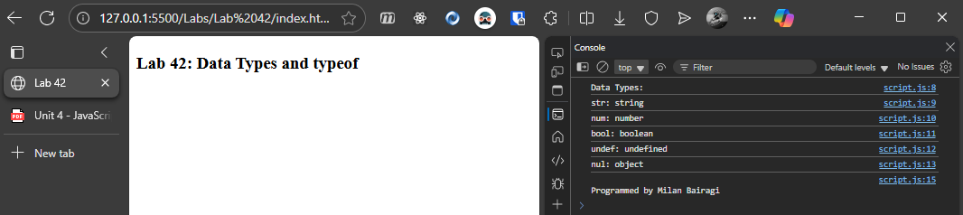

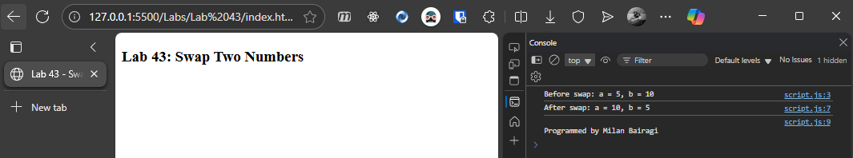

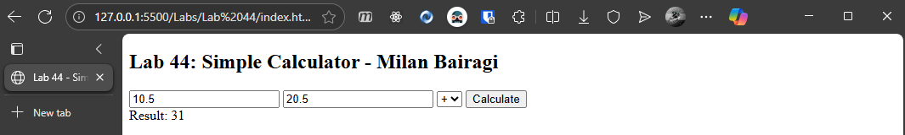

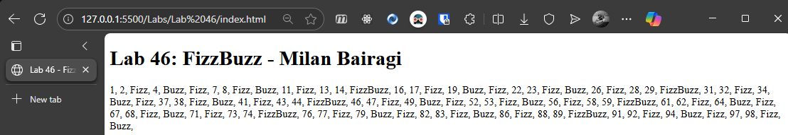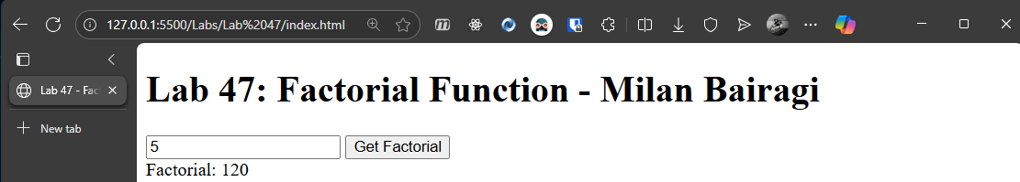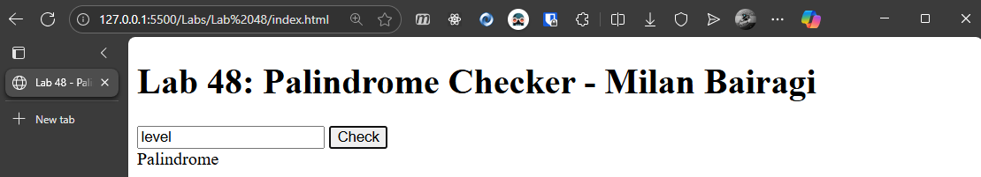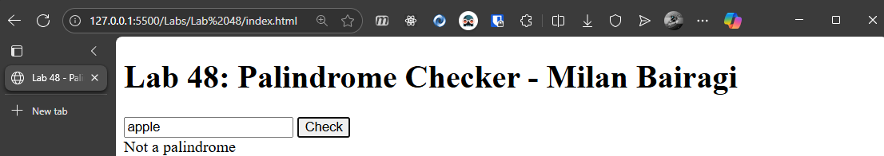

**Output**

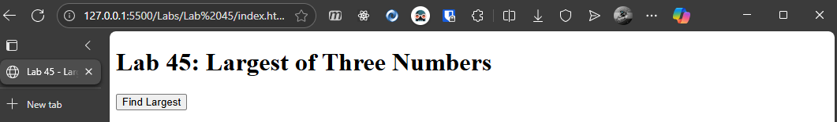

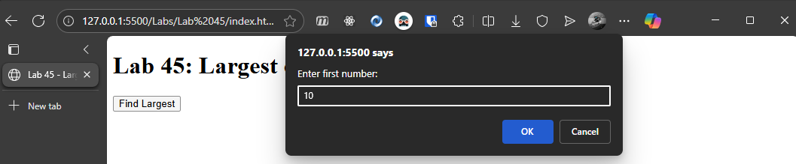

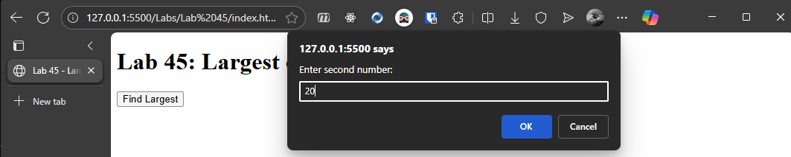

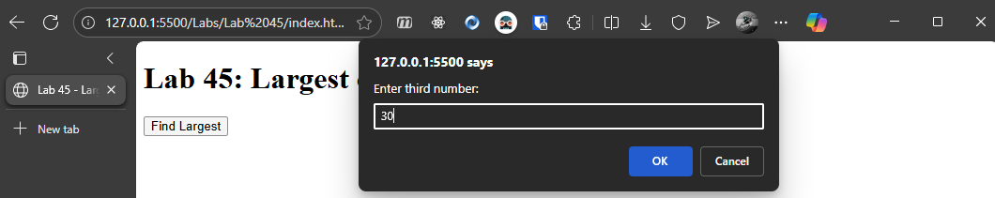

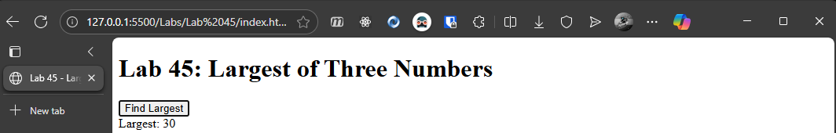

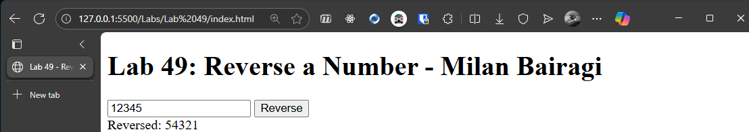

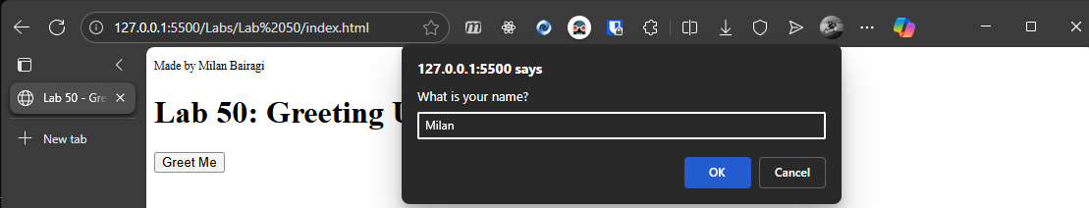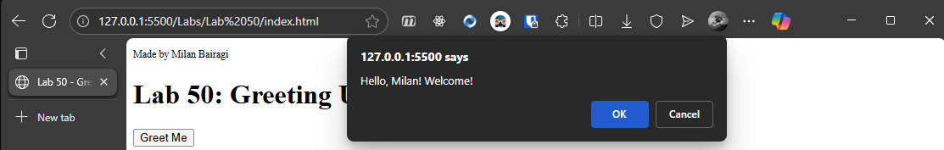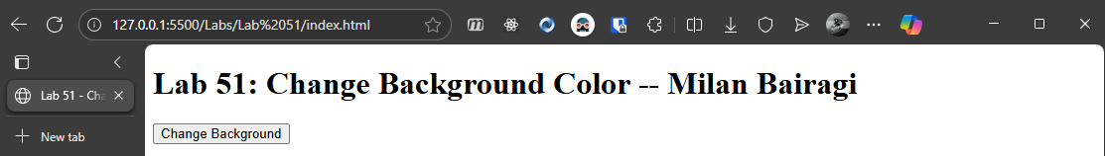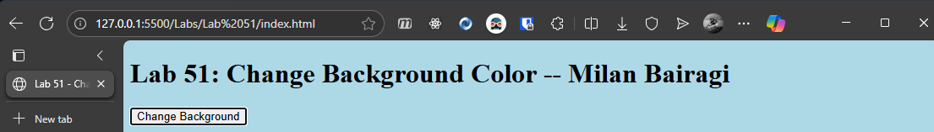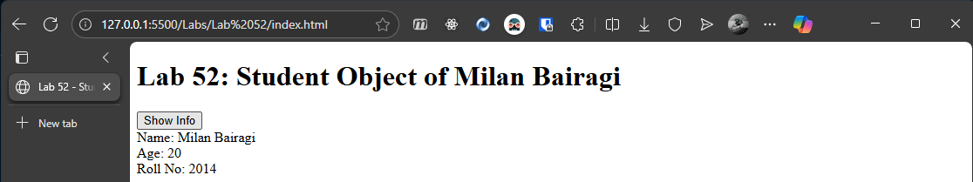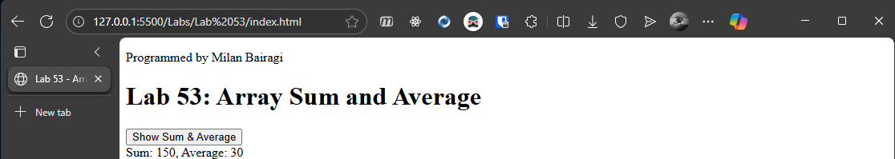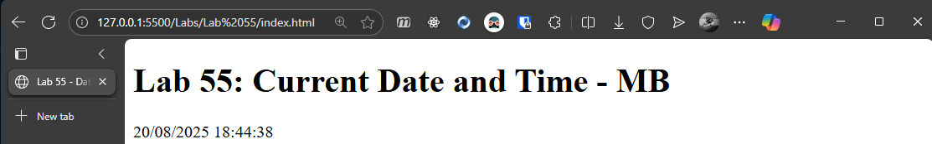

**OUTPUTS:**

**Original**

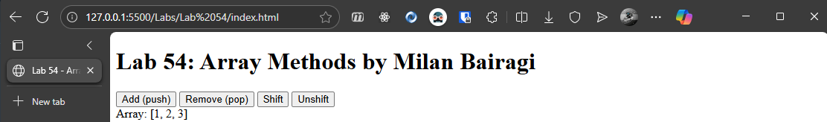

**PUSH** 4:

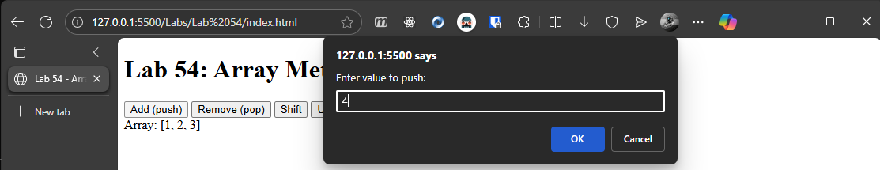

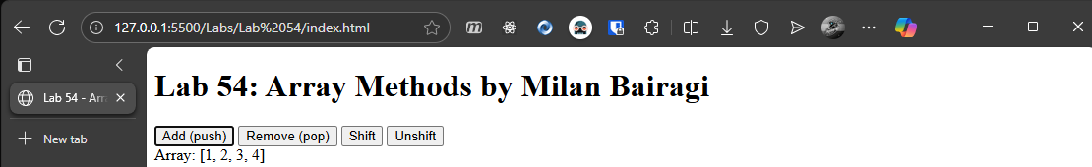

**POP**:

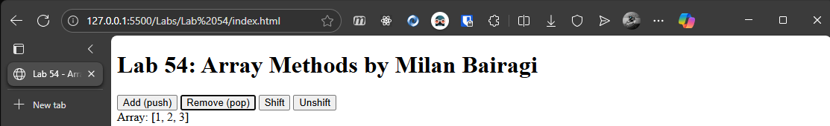

**SHIFT:**

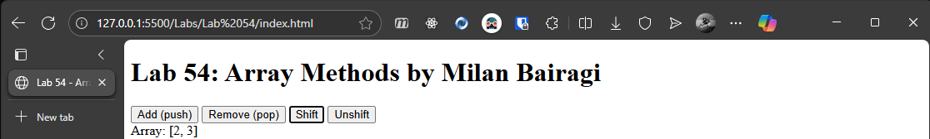

**UNSHIFT:**

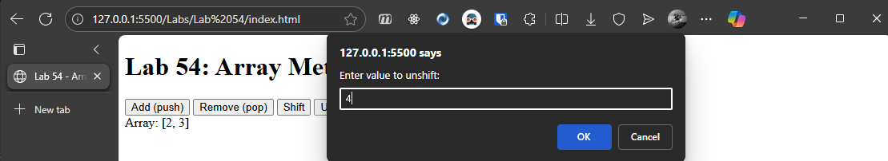

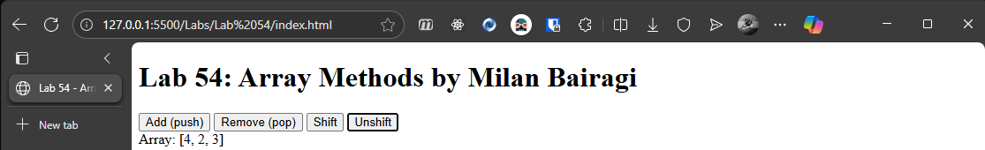

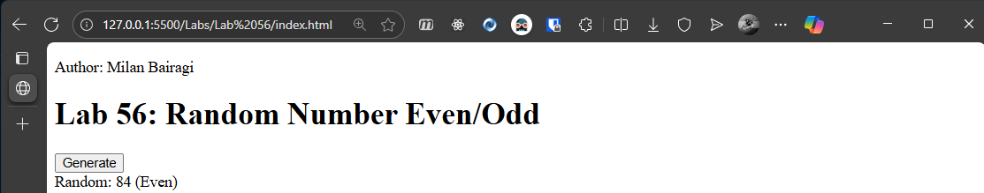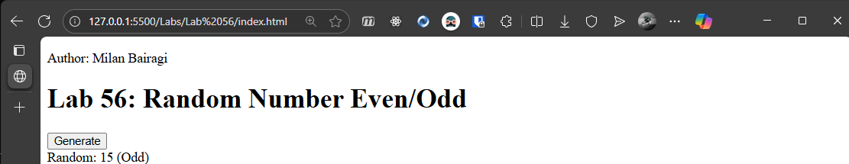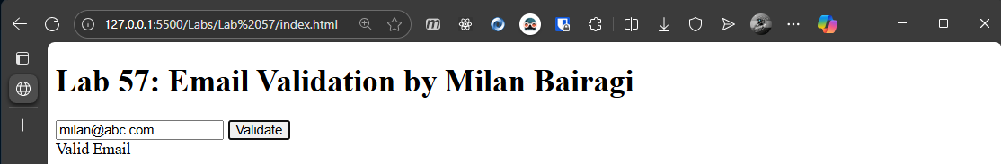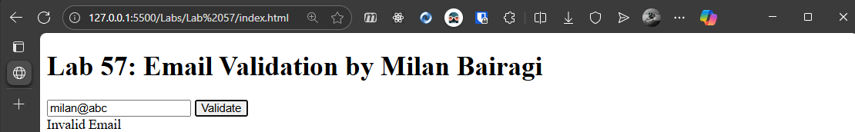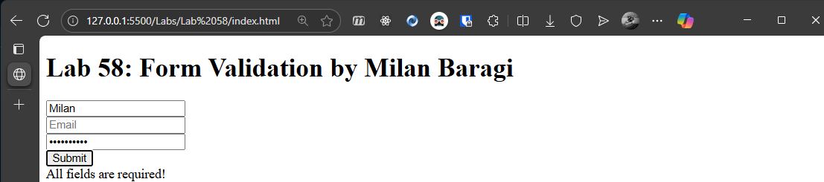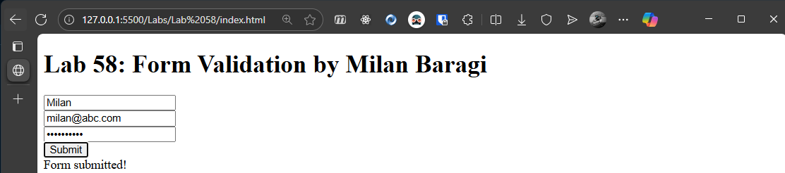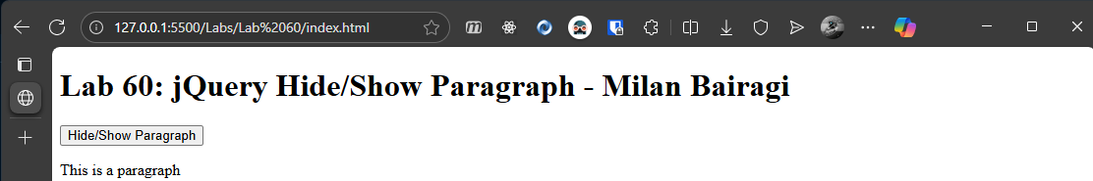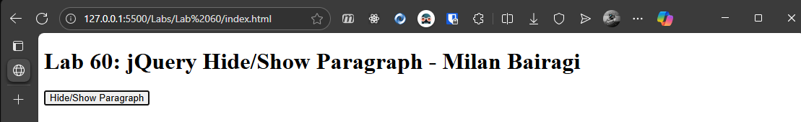

**Outputs:**

No Theme is selected:

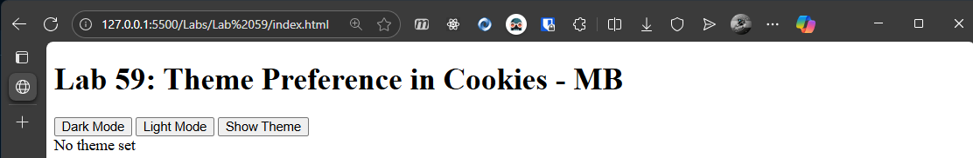

Setting dark mode:

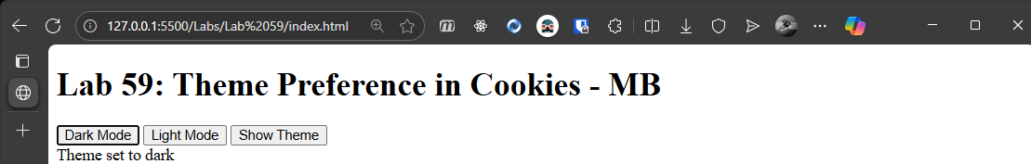

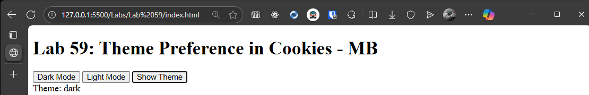

Setting light mode:

